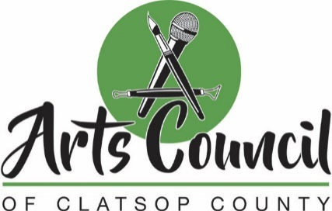
Meeting Minutes
Tuesday, Dec. 15 2020 @ 11:00 a.m.
***Meeting Held Remotely Via Google Meet***

- Call to Order/Roll Call
Call to order: 11:04 AM

Present: Dave Ambrose, Stuart Emmons, Sarah Andrews-Collier, Katherine Lacaze, Sheila Martin, Tracy Abel, Harold Gable
Others: Sarah Nebeker
Guests: Merillyn Taylor, Danyelle Tinker-Lowder, Jennifer Crockett
Absent: None

2. Additions/Deletions/Modifications of the Agenda
No modifications were made.

3. Approval of Minutes from Nov. 17, 2020 Meeting
The minutes were approved. (Harold/Sarah)

4. General Business
Arts & Economic Prosperity Study
- Dave gave an update on the study. Currently, the study will cost an estimated $6,500 for participation. The Oregon Arts Council will likely fund half, which means the remaining $3,250 will be the responsibility of the county.
- The Arts Council budget has been cut in half from $5,000 to $2,500 for the current fiscal year.
- Arts Council members gave an overview of the Arts & Economic Prosperity Study for the benefit of prospective council members. The council members will work together to conduct the survey and gather data in 2022. The information is used by the Americans for the Arts to assign a tangible number to the value of arts in the community.
- Sarah N. said information from the last study helped elevate the importance of the arts in the minds and opinions of local officials and business owners. It demonstrates that arts are a vital part of the economy.

Arts Council Strategic Plan
- Sheila gave an overview of the Arts Council’s draft strategic plan, which was developed during a workshop in February. The strategic plan outlines six primary goals with objectives.
- Council members approved the plan. (Tracy/Harold)
- Dave said he would plan to make a presentation to the County Commission, giving an update on what the Arts Council is involved with and planning.

Video Project
- Dave shared that some nonprofit arts organizations and groups are considering crafting a three- to five-minute video or a couple shorter videos. Jennifer Crockett is spearheading the coalition of performing arts groups in the county.
- According to Jennifer, it’s still early days, but the idea is to use the video for advocacy work, community engagement and education. She said the idea is to develop three short videos that could be part of a campaign for community education and engagement. Getting all the organizations involved and ensuring several different voices are included would be really powerful.

Community Updates
- Arts Council members and others at meeting gave an update on what they are involved with and arts-related news from around the county.

Arts Council Vacancies
- Dave shared with the prospective Arts Council members that there are five candidates for four slots. The Arts Council can make a recommendation to the County Commission, but that entity is solely responsible for appointments.
- Arts Council members discussed the idea of expanding membership from “seven to nine” to “nine to 11.” Harold said that would be advantageous to ensure there is a quorum at meetings and to have extra help with the survey in 2022.
- The council agreed to have Katherine and Sheila draft language to present to the County Commission to that effect. They also will work on edits to the bylaws to present to the county.

5. Adjournment
The meeting was adjourned at 12:13 p.m.

