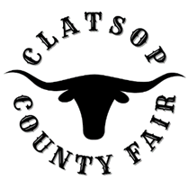
Board of Directors
September, 6 2022
board Members
Mike Autio, Chair
Kallie Linder
Jack Ficken
Brittany Israel
Matt Bellingham
Jason Brim – Interim Manager

- Call to Order
- Roll Call
- Meeting Minutes
- PUBLIC COMMENT – At this time anyone wishing to address the Fair Board concerning items of interest not already on the Agenda may do so. The person addressing the Fair Board will, when recognized, give their name and address for the record. All remarks will be addressed to the whole Board and limited to 3 minutes per person. Fair Board members reserve the right to delay any action, if required, until such time when they are fully informed and the matter is scheduled as an agenda item.

- Order of Business
  - Cowan Custom Farm Proposal
  - RC Plane Club
  - Quinceanera Contracts
- Board Member/Staff Communications
  - Romeo Ent. Group Contract Agreement- Potential Interests
  - Business Oregon Grant Approval issued $277,777 for capital improvements.
- Report from County Commissioner Bangs
- Adjournment

