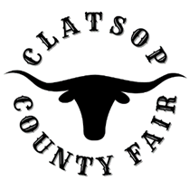
Board Meeting Minutes
July 5, 2022
board Members Present
Mike Autio, Chair
Kallie Linder, Vice Chair
Jack Ficken
Brittany Israel
Matt Bellingham
Jessica Narkaus - Administrative Coordinator
Jason Brim – Interim Manager
Call to Order at 5:30 by Mike Autio.
Roll Call – all board members in attendance.
Public Comment –None at this time.
Managers Update
Fair set up is scheduled to begin on July 17
Discussion about Ax Throwing booth at fair. At this time the board has decided to not bring in the Ax Throwing booth for Fair due to high cost of operation.
The board does approve American Thunder Monster truck rides for $5 all week of Fair.
Trace Adkins concert sales and locations are performing well.
A committee for the concert has been established to ensure details of concert are meet.
Jack Ficken, Brittany Israel and Jason Brim will be members of this committee.
Financial Statement was presented and reviewed by board.
Report from County Commissioner. Commissioner Bangs was not available for meeting.
Adjournment of meeting at 6:00 by Mike Autio

